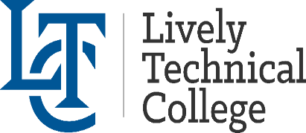 Get your 2025-2026 textbooks and
uniforms on Financial Aid

Fall 2025 | Purchasing Dates
July 1, 2025 (RN) | July 7, 2025 - July 11, 2025
July 21, 2025 (LPN) | July 24, 2025-July 31, 2025
July 29, 2025 (Medical Assisting) | August 4, 2025 – August 8, 2025
August 5, 2025 (Aviation) | August 11, 2025 – August 15, 2025
August 11, 2025 (PCT, Massage) | August 14, 2025 – August 21, 2025
August 11, 2025 (All other programs) | August 20, 2025 - August 28, 2025
CNA, Phlebotomy, Facials, Nails | First day of class
Sept 8, 2025 (Central Sterile) | Sept 15,2025 – Sept 18,2025
Cosmo Day (start Aug25 only- Senior kit) | Dec 1, 2025 - Dec 2, 2025
Spring 2026 | Purchasing Dates
January 7, 2026 (Aviation) | January 12, 2026 – January 16, 2026
January 7, 2026 (Health Ed Classes) | January 12, 2026 – January 16, 2026
January 7, 2026 (All other programs) | January 20, 2026 – January 28, 2026
CNA, Phlebotomy, Facials, Nails | First day of class
Cosmo Night (start Aug25 only – Senior kit) | April 13, 2026 – April 14, 2026
Cosmo Day (start Jan26 only – Senior kit) | April 27, 2026 – May 1, 2026
Summer 2026 | Purchasing Dates
CNA, Phlebotomy, Nails, Facials | First day of class
Pell funds may only be used to purchase books and supplies authorized by instructors. If you are using Pell funds and need to withdraw during
the semester, you will be responsible for reimbursing the cost of books and supplies you received. You must have your current Student ID
with you at the time of purchase. No returns or refunds of bookstore items.
Bookstore Information
Location: Building 8, Registration Window • Monday-Friday: 8:00 am – 4:00 pm

